Trigonometric Identities:

Key Points:
- Fundamental Identities:
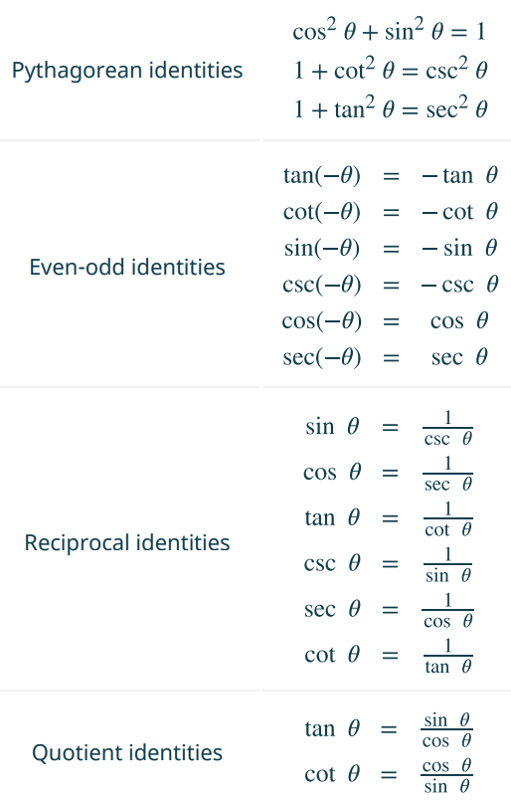
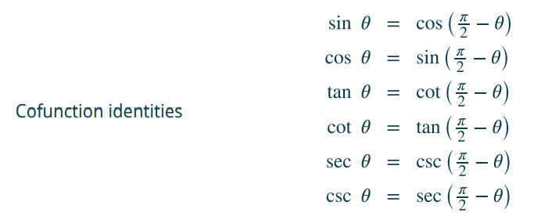
- Sum and Difference Identities
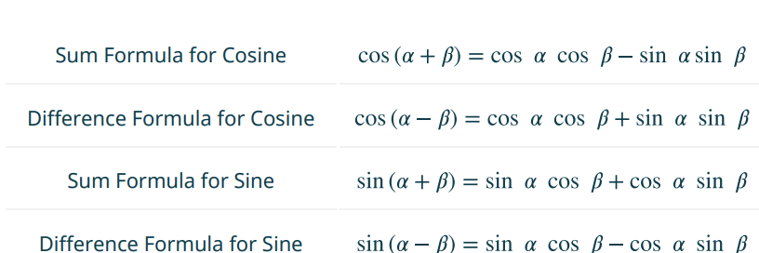
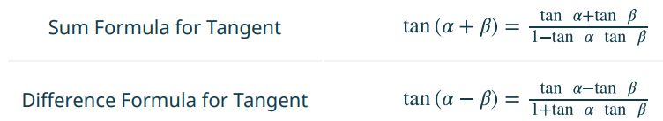

- Double-Angle, Half-Angle, and Reduction Formulas:
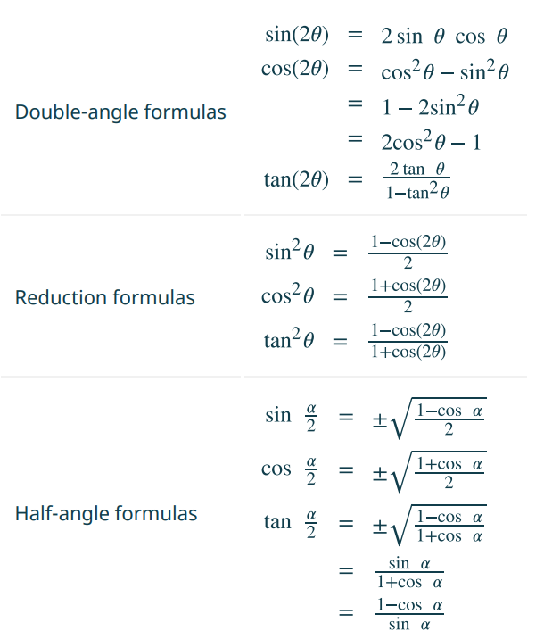

- Sum-to-Product and Product-to-Sum Formulas
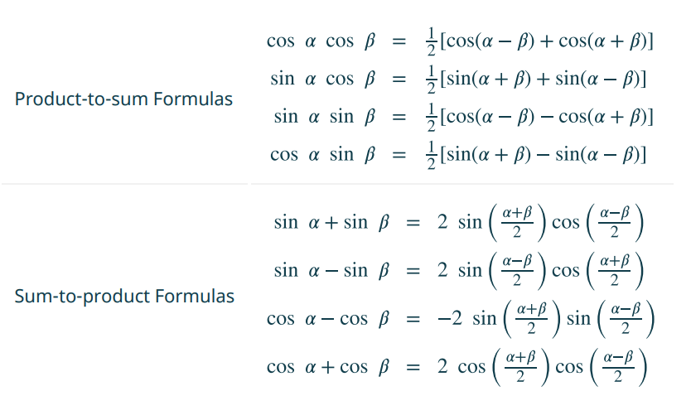
- There are multiple ways to represent a trigonometric expression. Verifying the identities illustrates how expressions can be rewritten to simplify a problem.
- Simplifying one side of the equation to equal the other side is another method for verifying an identity.
- It is often useful to begin on the more complex side of the equation
- Verifying an identity may involve algebra with the fundamental identities.

Trigonometric Identities Videos:
- Verifying the Fundamental Trigonometric Identity: Examples 1-2
- Verifying the Fundamental Trigonometric Identity: Examples 3-4
- Using the Sum and Difference Formulas: Examples 5-6
- Using the Sum and Difference Formulas: Examples 7-8
- Using the Double Angle Formulas: Examples 9-11
- Using the Reduction Formulas: Example 12
- Using the Half Angle Formulas: Example 13
- Expressing Products as Sum: Examples 14-16
- Expressing Sum as Product: Example 17
- Verifying an Identity: Example 18

Practice Exercises:

- Use basic identities to simplify the expression.

$$\sec{x} \cos{x}+\cos{x-\frac{1}{\sec{x}}}$$

- Determine if the given identities are equivalent.

$$\sin^{2}{x}+\sec^{2}{x}-1=\frac{\left(1-\cos^{2}{x}\right)\left(1+\cos^{2}{x}\right)}{\cos^{2}{x}}$$

For exercises 3 -7 use the sum and difference identities:
- Find the exact value of: $\tan\left(\frac{7π}{12}\right)$

- Find the exact value of : $\sin\left({70}^{°}\right)\cos\left({25}^{°}\right)-\cos\left({70}^{°}\right)\sin\left({25}^{°}\right)$

- Prove the identity: $\cos\left(4x\right)-\cos\left(3x\right)\cos\left(x\right)=\sin^{2}{x-4\cos^{2}{x}}\sin^{2}{x}$

- Simplify the expression: $\frac{\tan\left(\frac{1}{2}x\right)+\tan\left(\frac{1}{8}x\right)}{1-\tan\left(\frac{1}{2}x\right)\tan\left(\frac{1}{8}x\right)}$

- Find the exact value of : $\tan\left(\sin^{-1}\left(0\right)+\sin^{-1}\left(\frac{1}{2}\right)\right)$

For exercises 8 – 12, use the Double-Angle, Half-Angle, and Reduction Formulas:
- Find the exact value of : $\sin\left(2θ\right),\cos\left(2θ\right)$ and $\tan\left(2θ\right)$ given $\sec\left(θ\right)=-\frac{5}{3}$ and $θ$ is in the interval $\left[0,2π\right]$

- Find the exact value of $\sec\left(\frac{3π}{8}\right)$

- Use the following figure to find the value of :

$\sin\left(\frac{β}{2}\right), \cos\left(\frac{β}{2}\right), \tan\left(\frac{β}{2}\right), \sin\left(\frac{α}{2}\right), \cos\left(\frac{α}{2}\right), \tan\left(\frac{α}{2}\right)$

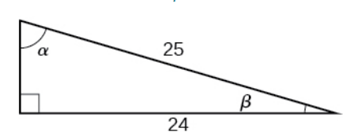

- Verify the identity: $\cot\left(x\right) \cos\left(2x\right)=-\sin\left(2x\right)+\cot\left(x\right)$

- Rewrite the expression with no powers: $\tan^{2}{x} \sin^{3}{x}$

For exercises 13 –16 , use Sum-to-Product and Product-to-Sum Formulas:

- Find the exact value of: $2\sin\left(\frac{2π}{3}\right)\sin\left(\frac{5π}{6}\right)$

- Find the exact value of: $\sin\left(\frac{π}{12}\right)-\sin\left(\frac{7π}{12}\right)$

- Change the function from the product to a sum: $\sin\left(9x\right)\cos\left(3x\right)$

- Change the function from sum to a product: $\sin\left(11x\right)+\sin\left(2x\right)$

Answers:

- 1

- Yes

- $-2-\sqrt{3}$

- $\frac{\sqrt{2}}{2}$

- 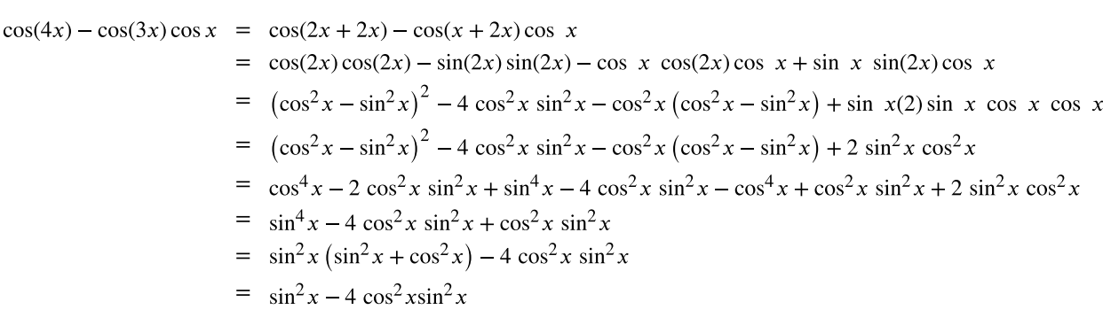

- $\tan\left(\frac{5}{8}x\right)$

- $\frac{\sqrt{3}}{3}$

- $-\frac{24}{25}, -\frac{7}{25},\frac{24}{7}$

- $\sqrt{2\left(2+\sqrt{2}\right)}$

- $\frac{\sqrt{2}}{10},\frac{7\sqrt{2}}{10}, \frac{1}{7}, \frac{3}{5}, \frac{4}{5}, \frac{3}{4}$

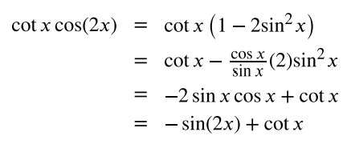

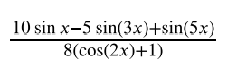

- $\frac{\sqrt{3}}{2}$

- $-\frac{\sqrt{2}}{2}$

- $\frac{1}{2}\left(\sin\left(6x\right)+\sin\left(12x\right)\right)$

- $2\sin\left(\frac{13}{2}x\right)\cos\left(\frac{9}{2}x\right)$

